SQL Queries
- List the employee ID, full name, and job title of all employees.
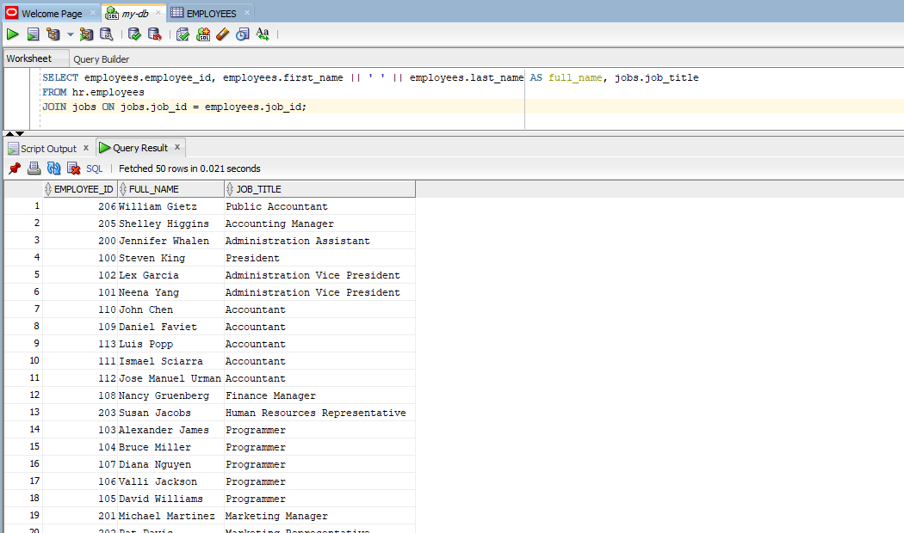

- Count the number of employees in each job title. Show only job titles that have more than 3 employees.
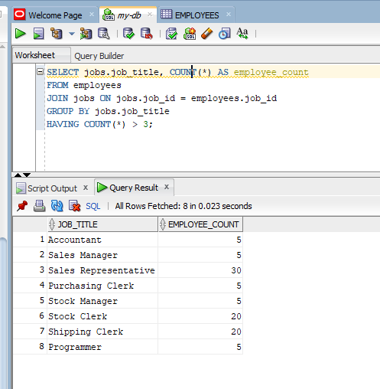

- List the distinct locations (city and country) where the company has departments.
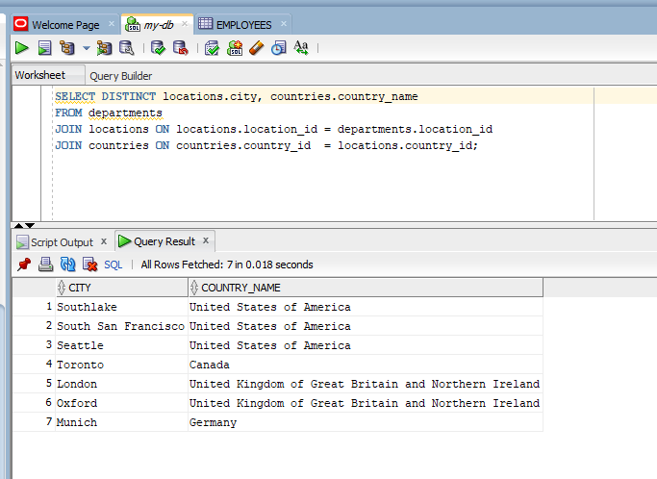

- Find all employees who earn between $3000 and $7000 per month. Include the
employee ID, full name, and salary, sorted by salary in descending order.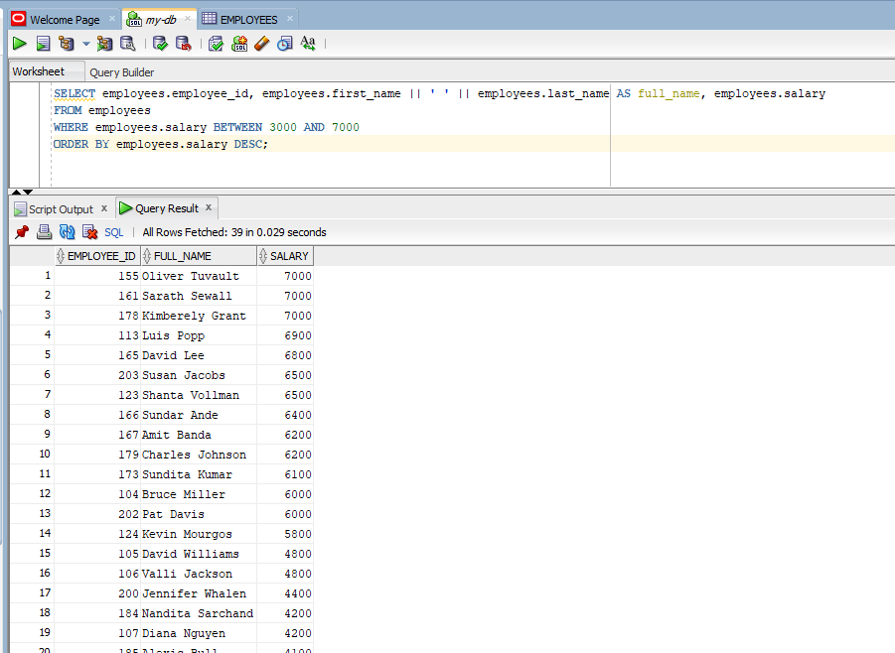

- Find the highest salary in the company, along with the name of the employee who earns it.
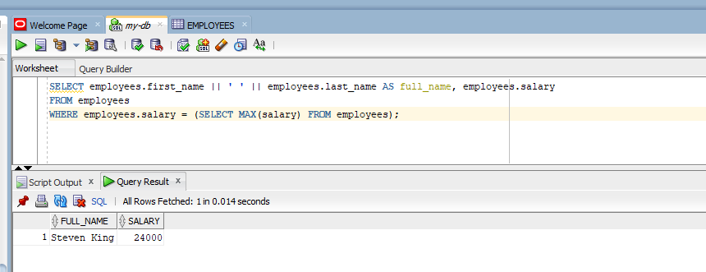

- Find the most recent (latest) hire date in the company. Just show the date.
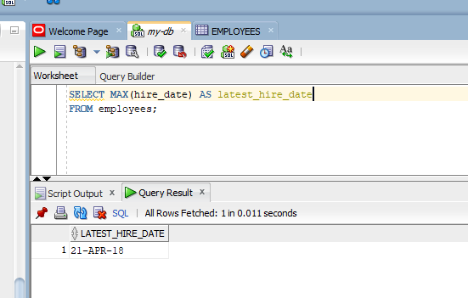

- List all employees who were hired before January 1, 2005. Include the employee ID, full name, and hire date.
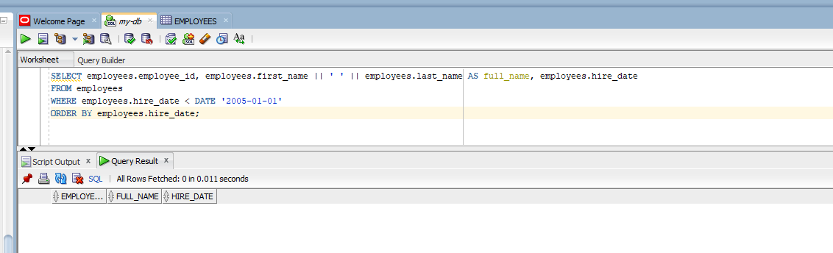

- Calculate the total salary paid in each department. Include the department name and the total.
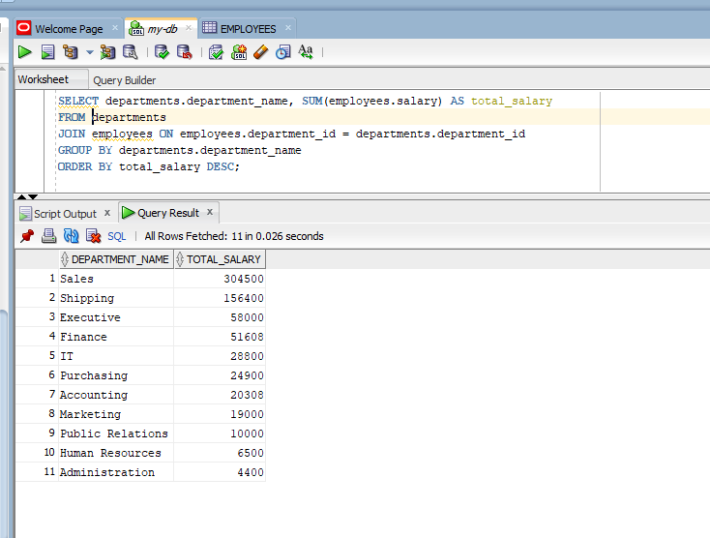

- List the names of all departments that currently have no employees.
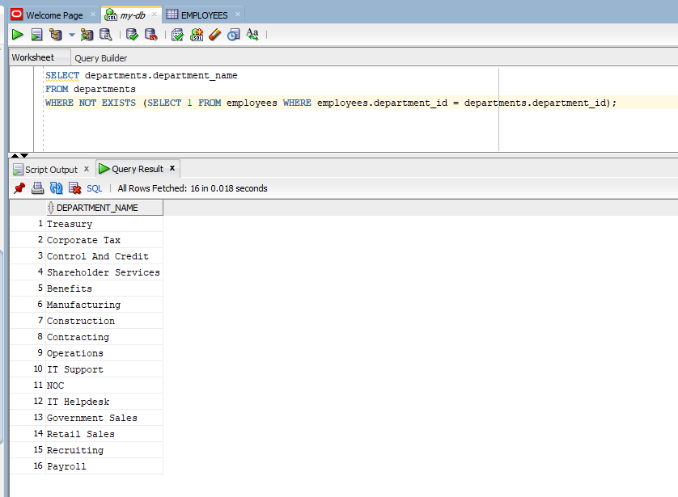

- Find all employees whose job title is 'Programmer' or 'Accountant'. Include the employee ID, full name, and job title.
